A periodic table is needed for this test.

**1** Complete the table below:

|  |  |  |  |
| --- | --- | --- | --- |
| **Particle** | **Mass** | **Charge** | **Positions** |
| Proton |  | +1 |  |
|  | 1 |  | In nucleus |
|  |  | -1 |  |

(4)

**2**

**a)** Below are diagrams of four atoms.

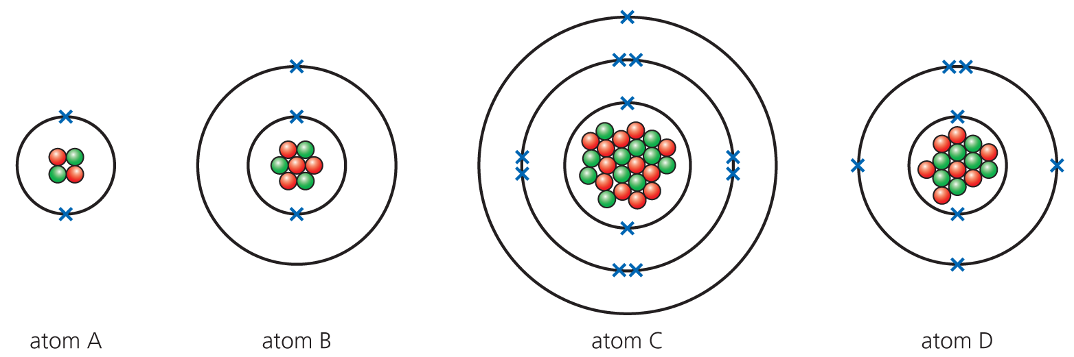

Using the periodic table, answer the following questions:

**i)** Which atom has the electronic configuration of 2,8,1? (1)

**ii)** Which of the above shows an atom of lithium? (1)

**iii)** Which element is Atom C? (1)

**iv)** What is the mass number of Atom D? (1)

**b)** Fill in the gaps below:

*Isotopes have the same number of __________ but a different number of _______*. (2)

**c)** Boron (atomic number 5) exists as two common isotopes: boron 10 and boron 11.

**i)** Complete the table below:

|  |  |  |  |  |
| --- | --- | --- | --- | --- |
| **Isotope** | **Number of protons** | **Number of neutrons** | **Number of electrons** | **% abundance** |
| Boron 10 | 5 |  |  | 20% |
| Boron 11 |  |  |  | 80% |

(5)

**ii)** Find the relative atomic mass of boron and give your answer to 1 decimal place. Show your workings. (3)

**d)** The table below gives some information for several atoms and simple ions. Complete the table.

|  |  |  |
| --- | --- | --- |
| **Atom/Ion** | **Number of protons** | **Electron structure** |
|  | 8 | 2,6 |
| Si |  |  |
| Cl− |  |  |
|  | 12 | 2,8 |

(6)

**3** Sodium and potassium are both in Group 1 of the periodic table.

**a)** How many electrons do they both have in their outer shell? (1)

**b)** Why are they stored in oil? (2)

**c)** The Group 1 metals show a trend in their reactivity towards water. What is the reaction that occurs with water? (Equations would be helpful.) What is the trend in reactivity and why does this occur? (6)

**4** Chlorine, bromine and iodine are Group 7 elements.

**a)** In terms of electronic structure, why are these elements placed in Group 7? (1)

**b)** Why is chlorine added to drinking water? (1)

**c)** The order of reactivity of the halogens can be found by displacement reactions. Complete the word equation: (2)

chlorine + potassium bromide → __________ _________ + _______________

**5**

**a)** Where in the periodic table are the transition metals? (1)

**b)** The transition metals have different properties from Group 1 metals. Place a tick in the box below to show if the property is from a Group 1 metal or a transition metal.

|  |  |  |
| --- | --- | --- |
| **Property** | **Transition metal** | **Group 1** |
| High melting point |  |  |
| Very soft |  |  |
| Compounds are white |  |  |
| High density |  |  |

(4)

**c)** Argon is used to fill light bulbs. Why is this gas used for this purpose? (1)

**6**

**a)** Which of the following are mixtures and which are compounds? Place a tick in the correct box.

|  |  |  |
| --- | --- | --- |
|  | **Compound** | **Mixture** |
| Sea water |  |  |
| Sugar |  |  |
| Air |  |  |
| Common salt |  |  |

(4)

**b)** The following are different methods of separating mixtures:

**Filtration  Distillation  Fractional distillation  Separating funnel  Chromatography**

Which method is the simplest method to separate:

**i)** Sand from water (1)

**ii)** Dyes in inks (1)

**iii)** Two immiscible liquids (1)

Total = 50

1

|  |  |  |  |
| --- | --- | --- | --- |
| Particle | Mass | Charge | Positions |
| Proton | **1** | +1 | **In nucleus** |
| **Neutron** | 1 | **0** | In nucleus |
| **Electron** | **1/2000** | **−1** | **In shells** |

All 7 = 4 marks, 6-5 = 3 marks, 4-3 = 2 marks, 2-1 = 1 mark (4)

2

a)

i) C (1)

ii) B (1)

iii) Sodium (1)

iv) 14 (1)

b) protons; neutrons (2)

|  |  |  |  |  |
| --- | --- | --- | --- | --- |
| **Isotope** | **Number of protons** | **Number of neutrons** | **Number of electrons** | **% abundance** |
| Boron 10 | 5 | **5** | **5** | 20% |
| Boron 11 | **5** | **6** | **5** | 80% |

i)

(5)

ii) (10 × ) + (11 × ) = 10.8 (3)

d)

|  |  |  |
| --- | --- | --- |
| **Atom/Ion** | **Number of protons** | **Electron structure** |
| **O** | 8 | 2,6 |
| Si | **14** | **2,8,4** |
| Cl**−** | **17** | **2,8,8** |
| **Mg2+** | 12 | 2,8 |

(6)

3

a) 1 (1)

b) *Reacts* with the *oxygen* in the air. (2)

c)

|  |  |
| --- | --- |
| **Marks** |  |
| 6-5 | At least three different points well expressed |
| 4-3 | A couple of points mentioned |
| 2-1 | Not much detail |

Points that can be made:

* Hydroxide solution formed.
* Hydrogen gas given off.
* Metal + water 🡪 metal hydroxide + hydrogen
* 2M + 2H2O 🡪 2MOH + H2 – (Students deserve good credit for getting this one)
* Reactivity increases down group.
* Electron further away from nucleus (bigger atom) (OWTTE).
* More easily removed.

4

a) Seven electrons in outer shell (1)

b) Kills bacteria/micro-organisms. (1)

c) → potassium chloride + bromine (2)

5

a) In between Groups 2 and 3 / in middle (1)

b)

|  |  |  |
| --- | --- | --- |
| **Property** | **Transition metal** | **Group 1** |
| High melting point | **🗸** |  |
| Very soft |  | **🗸** |
| Compounds are white |  | **🗸** |
| High density | **🗸** |  |

(4)

c) Inert/unreactive/full outer shell (1)

6

a)

|  |  |  |
| --- | --- | --- |
|  | **Compound** | **Mixture** |
| Sea water |  | **🗸** |
| Sugar | **🗸** |  |
| Air |  | **🗸** |
| Common salt | **🗸** |  |

(4)

b)

i) Filtration (1)

ii) Chromatography (1)

iii) Separating funnel (1)

TOTAL = 50